

A Project Report

on

**Traffic Sign Recognition**

Submitted By:

Student’s Name: Enrollment No:

Ankit Senjaliya19BT04046

Bhautik Karma 19BT04017

Amish Kajavadra 19BT04015

Darshan Lakhani 19BT04021

Sagar Vankani 19BT04058

Nikunj Sanghani 19BT04044

IN

COMPUTER SCIENCE AND ENGINEERING

Guided by:

Dr Saurabh Shah

Professor and Dean, School of Technology

Academic Year: 2020-21

### GSFC University

### School of Technology

### Computer Science and Engineering

**CANDIDATES’ DECLARATION**

We, the students of Computer Science & Engineering hereby declare that the project report entitled **“Traffic Sign Recognition”** is our own work conducted under the supervision of the guide **(Dr./Prof) Saurabh Shah** for the subject **AI/ML** in Semester IV, Academic Year 2020-21.

We further declare that to the best of our knowledge that the report contains the original work of the project carried out as the partial fulfillment of the assignment submission.

Student’s Name: Enrollment No:

Ankit Senjaliya19BT04046

Bhautik Karma 19BT04017

Amish Kajavdra 19BT04015

Darshan Lakhani 19BT04021

Sagar Vankani 19BT04058

Nikunj Sanghani 19BT04044

## CERTIFICATE

### This is to certify that the project entitled “Traffic Sign Recognition” is a bonafied report of the work carried out by Ankit Senjaliya (19BT04046), Bhautik Karma (19BT04017), Amish Kajavdra (19BT04015), Sagar Vankani (19BT04058), Darshan Lakhani (19BT04021), Nikunj Sanghani (19BT04044)for AI/ML subject in Semester IV of Computer Science & Engineering under the guidance and supervision of Dr. Saurabh Shahfor the partial fulfillment of assignment submission.

**To the best of my knowledge and belief, this work embodies the work of candidates themselves, have duly completed, fulfills the requirement of assignment submission and is up to the standard in respect of content, presentation and language.**

Dr. Saurabh Shah

Project Guide

### GSFC University

### School of Technology

### Computer Science and Engineering

INDEX (TABLE OF CONTENTS)

Certificate……………………………………………………………….

Acknowledgement………………………………………………………

Abstract…………………………………………………………………

1). Introduction…………………………...……………………….. ……

1.1) Project Summary………………….…………………………….

1.2) Purpose……...……………………………………………….….

1.3) Objectives…….……………………………………………...….

1.4) Hardware And Software Requirement……………….…….…...

2). System Analysis and Design……………………...……...………….

2.1) Problems and Weakness Of current System……………………

2.2) Requirements of New System………………………………......

3.) Implementation and Screenshots……………………………..…… …

4.) Conclusion………………………………………………………….

5.) References………………………………………………………….

**PROJECT REPORT CONTENTS**

**CERTIFICATE**

This is to certify that the project entitled “Traffic Sign Recognition” is a bonafied report of the work carried out by Ankit Senjaliya (19BT04046), Bhautik Karma (19BT04017), Amish Kajavdra (19BT04015), Sagar Vankani (19BT04058), Darshan Lakhani (19BT04021), Nikunj Sanghani (19BT04044)for AI/ML subject in Semester III of Computer Science & Engineering under the guidance and supervision of Dr. Saurabh Shahfor the partial fulfillment of assignment submission.

To the best of my knowledge and belief, this work embodies the work of candidates themselves, have duly completed, fulfills the requirement of assignment submission and is up to the standard in respect of content, presentation and language.

Dr. Saurabh Shah

Professor and Dean

**ACKNOWLEDGEMENT**

* Apart from my efforts, the success of any project depends largely on the encouragement and guidelines of many others. I take this opportunity to express my gratitude to the people who have been instrumental in the successful completion of this project.
* I would like to show my greatest appreciation to Dr. Saurabh Shah, external supervisor at SLR Infotech and the entire faculty of the department of Computer Science and Engineering at GSFC University from Baroda, where we have learnt the basics Of Computer Science and whose informal discussions and able guidance became light for us in the entire duration of this work.
* I can’t say thank you enough for their tremendous support and help. I feel motivated and Encouraged every time I work on this project meeting. Without their encouragement and Guidance this project would not have materialized.
* The guidance and support received from the members who contributed and who are contributing to this project are vital for the success of the project. I am grateful for their constant support and efforts.

**ABSTRACT**

* In recent years, the deep learning methods for solving classification problem have become extremely popular. Due to its high recognition rate and fast execution, the convolutional neural networks have enhanced most of computer vision tasks, both existing and new ones. In this article, we propose an implementation of traffic signs recognition algorithm using a convolution neural network. Training of the neural network is implemented using the TensorFlow library and massively parallel architecture for multithreaded programming CUDA. The entire procedure for traffic sign detection and recognition is executed in real time on a mobile GPU. The experimental results confirmed high efficiency of the developed computer vision system.

**INTRODUCTION**

* Project Summary :-
* Development of the technical level of modern mobile processors enabled many vehicle producers to install computer vision systems into customer cars. These systems help to significantly improve the safety and implement an important step on the way to autonomous driving. Among other tasks solved with computer vision, the traffic sign recognition (TSR) problem is one of the most well-known and widely discussed by lots of researchers.
* Purpose :-
* However, the main problems of such systems are low detection accuracy and high demand for hardware computational performance, as well as the inability of some systems classifies the traffic signs from different countries. Recognition of traffic signs is usually solved in two steps: localization and subsequent classification. There are many different localization methods.
* Objectives :-
* In papers and the authors proposed effective implementations of the image preprocessing and traffic signs localization algorithms, which performed in real time. Using a modified Generalized Hough Transform (GHT) algorithm, the solution allowed determining the exact coordinates of a traffic sign in the acquired image. Thus, in the classification stage, the simple template matching algorithm was used. Combined with precise localization stage, this algorithm showed the final results of 97.3% accuracy of traffic sign recognition. The dataset from GTSDB was used for training and testing the developed algorithms. Figure 1 shows the images for training the traffic signs recognition algorithm and testing the localization algorithm.
* Hardware And Software Requirement :-

* Hardware Requirement :-

* Hard disk :- 500 GB
* RAM :- 8 GB
* System :- Intel Core I3 Processor.
* Monitor :- Standard LED Monitor.
* Input Devices :- Keyboard
* Software Requirement
* Languages :- Python
* Technologies :- Jupyter Notebook
* Data base :- Germen Traffic Sign Recognition
* Operating System :- Windows 10

**SYSTEM ANALYSIS AND DESIGN**

* Problems and Weakness Of current System :-

* There are many errors but whenever user upload image from file there are some permission issue for project.

* Requirements of New System :-
* **User Requirements :-**
* There should be software which allocate image and maintain their sign and generate messages for customers.
* **System Requirements :-**
* There should be database backup of Traffic Sign Recognition There should be Python supported framework for the system. Operating system should be Windows XP or higher version of Windows.

**IMPLEMENTATION AND SCREEN SHOTS**

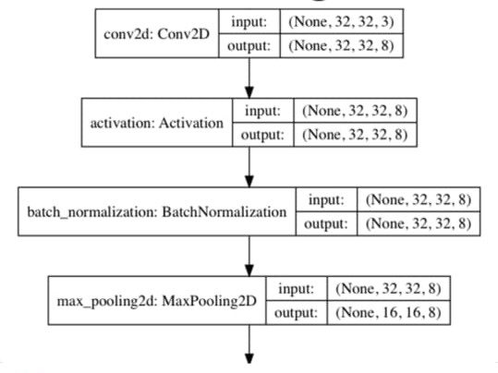

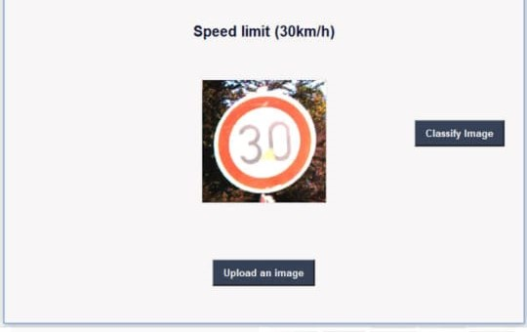

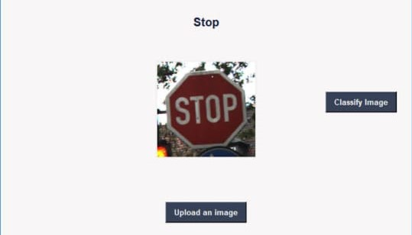

**CONCLUSION**

* This paper considers an implementation of the classification algorithm for the traffic signs recognition task. Combined with preprocessing and localization steps from previous works, the proposed method for traffic signs classification shows very good results: 99.94 % of correctly classified images. The proposed classification solution is implemented using the TensorFlow framework. The use of our TSR algorithms allows processing of video streams in real-time with high resolution, and therefore at greater distances and with better quality than similar TSR systems have. Full resolution makes it posiible to detect and recognize a traffic sign at a distance up to 50 m. The developed method was implemented on a device with Nvidia Tegra K1 processor. CUDA was used to accelerate the performance of the described methods. In future research, we plan to train the CNN to consider more traffic sign classes and possible bad weather conditions. In current, versions we Considered only daylight and good visibility

**REFERENCES**

* **Google.com**
* **Python Tutorial**